

Firmware Upgrade Guide_Linux

V1.7

Disclaimer

Customers must design and develop their products referring to the information provided in the document. The Company shall not be liable for any damage caused by failure to comply with relevant operation or specifications or rules. Due to product version upgrade or other reasons, the Company reserves the right to modify any information in this document at any time without prior notice and any responsibility. Unless otherwise agreed, all statements, information and suggestions in this document do not constitute any express or implied guarantee.

Copyright Notice

Copyright © 2023 Fibocom Wireless Inc. All rights reserved.

Unless specially authorized by the Company, the recipient of the documents shall keep the documents and information received confidential, and shall not use them for any purpose other than the implementation and development of this project. Without the written permission of the Company, no unit or individual shall extract or copy part or all of the contents of this document without authorization, or transmit them in any form. The Company has the right to investigate legal liabilities for any offense and tort in connection with violation of confidentiality obligations, or unauthorized use or malicious use of the said documents and information in other illegal forms.

Trademark Statement

新LOGO（蓝色）The trademark is registered and owned by Fibocom Wireless Inc.

Other trademarks, product names, service names and company names appearing in this document are owned by their respective owners.

Contact Information

Website: https://www.fibocom.com

Address: 10/F-14/F, Block A, Building 6, Shenzhen International Innovation Valley, Dashi First Road, Xili Community, Xili Subdistrict, Nanshan District, Shenzhen

Tel: 0755-26733555

Safety Instructions

Do not operate wireless communication products in areas where the use of radio is not recommended without proper equipment certification. These areas include environments that may generate radio interference, such as flammable and explosive environments, medical devices, aircraft or any other equipment that may be subject to any form of radio interference.

The driver of any vehicle shall not operate wireless communication products while controlling the vehicle, otherwise will be reduced the driver's control of the vehicle , resulting in safety risks.

Wireless communication devices do not guarantee effective connection under any circumstances, such as when the (U) SIM card is invalid or the device is in arrears. In an emergency, please use the emergency call function when the device is turned on, and ensure that the device is located in an area with sufficient signal strength.

Contents

Applicable Models 2

Change History 3

1 Introduction 4

2 Compilation 5

2.1 Upgrade Tool Package Introduction 5

2.2 Compile Upgrade Tool 6

2.2.1 Linux Upgrade Tool 6

2.2.2 Android Upgrade Tool 8

3 Upgrade 10

3.1 Local Upgrade 10

3.2 Viewing Upgrade Result 11

4 Upgrade Parameter Description 12

5 NV Restoration Commands 13

5.1 NV Restoration of MDM9X07 and MDM9205 Modules 13

5.2 NV Restoration of Other Modules 13

Applicable Models

|  |  |  |
| --- | --- | --- |
| No. | Applicable Model | Description |
| 1 | L716/L718 | ZTE V3E/T |
| 2 | L61x/LC61x/MC61x/LG61x | UNISOC 8910 |
| 3 | MC66x/MG66x | UNISOC 8850 |
| 4 | FG650/FG652/FM650 | UNISOC UDX710 |
| 5 | NL668/MC116/LC116 | QCOM MDM9x07 |
| 6 | MA510/MC109/MC100E | QCOM MDM9205 |
| 7 | FG10x/FM10x | QCOM X12 |
| 8 | FM150/FG150 | QCOM X55 |
| 9 | FM160/FG160 | QCOM X62 |
| 10 | FG621 | UNISOC SL8563 |
| 11 | LE270 | EC718 |
| 12 | FG190/FM190 | QCOM X72 |

Change History

|  |  |
| --- | --- |
| V1.6 (2024-03-11) | Add the usage description of the -c parameter |
| V1.6 (2024-03-01) | Add applicable model SDX72 |
| V1.5 (2023-11-23) | 1.Modify the FG621 chip signal  2. Added core shifting platform and related description of the platform |
| V1.4 (2023-11-07) | Improved the tool adaptation model and -r1 parameter description |
| V1.3 (2023-10-23) | The power-off message cannot be displayed during the upgrade |
| V1.2 (2023-08-23) | Modifying Parameters |
| V1.1 (2023-05-20) | Added the description of upgrading pcie ports on a Qualcomm platform |
| V1.0 (2022-08-28) | Initial version. |

1. Introduction

Upgrade_ tool is used for Linux and Android hosts to upgrade the firmware of Fibocom modules.

1. Compilation

* 1. Upgrade Tool Package Introduction

doc: Chinese and English guidance documents

misc_code: common code

qcom_code: Qcom modules upgrade code

zte_code: ZTE modules upgrade code

unisoc_code: Unisco modules upgrade code

eigencomm _code: eigencomm modules upgrade code

main.c: The program code

Makefile: Compiling configuration file for Linux Environment

Android.mk: Compiling configuration file for Android Environment

The detailed directory structure is as shown in the figure 1.

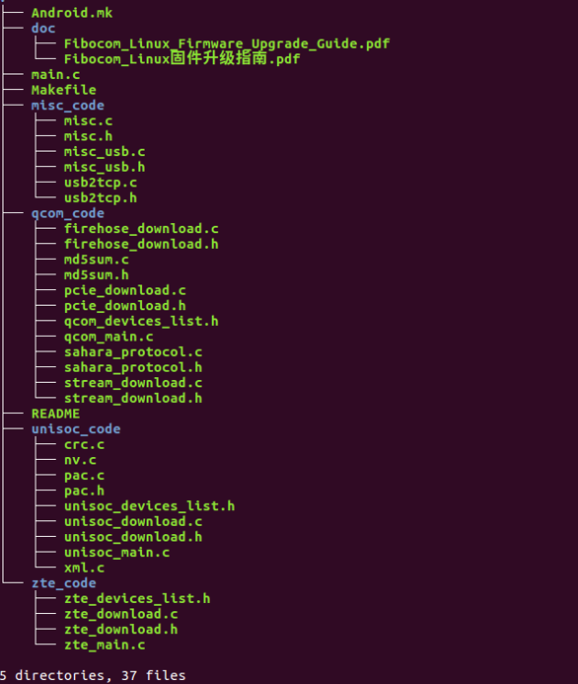

Figure 1. Directory structure

* 1. Compile Upgrade Tool
     1. Linux Upgrade Tool

Configure cross compilation tool

GCC is used by default. If arm GCC is required, set CROSS_COMPILE variable in Makefile.

As blow:

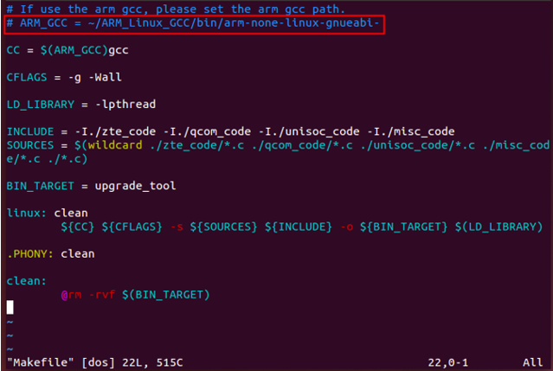

Figure 2. Makefile

Compilation

Put the upgrade tool code on the Linux host, then in the code directory, execute make. The upgrade_ tool will be generated if the compilation is OK.

As shown in the following figure.

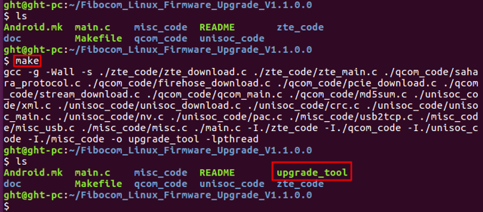

Figure 3. Compile generated result

|  |  |  |
| --- | --- | --- |
| C:\Users\Administrator\Desktop\图层 4.png |  | The eigencomm platform currently only supports 32-bit compilation, which includes - m32 in the compilation option. If an error is reported during the compilation process: sys/cdefs. h: No such file or directory, it indicates that the Linux host needs to install 32-bit library files. In Ubuntu, the sudo apt-get install libc6-dev-i386 command to install online. |

* + 1. Android Upgrade Tool

Put the upgrade tool code into the Android code directory.

Run source build/envsetup.sh.

Run lunch, and then select the build option.

Run mmm Fibocom_Linux_Firmware_Upgrade_XXX

If the compilation is successful, the upgrade_tool will be generated

The path of upgrade_tool will be displayed in the compilation log.

e.g.

out/target/product/msm8953_64/system/bin/upgrade_tool

|  |  |  |  |
| --- | --- | --- | --- |
|  | C:\Users\Administrator\Desktop\图层 4.png |  | Android system tools for Android 8 and higher are not currently compatible. |

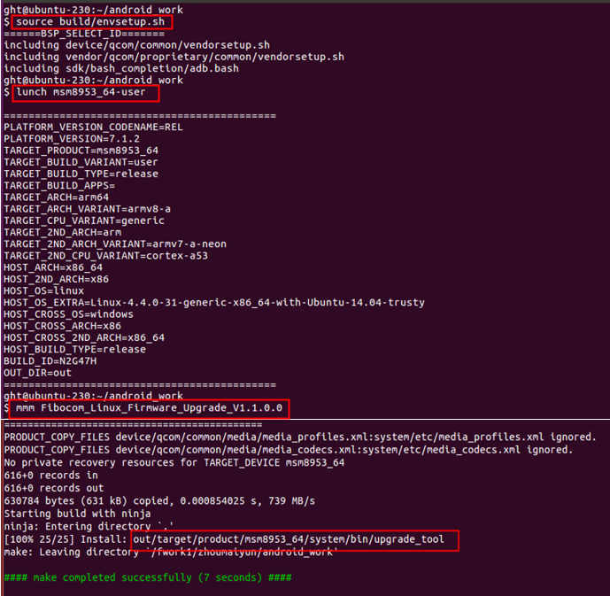

Figure 4. Android environment compilation procedure

1. Upgrade

* 1. Local Upgrade

1. Check whether the USB connection of the module is normal.

|  |  |  |  |
| --- | --- | --- | --- |
|  | C:\Users\Administrator\Desktop\图层 4.png |  | Qcom module:  If the qcom module is in normal mode, please send at+disk=0,0,0 to unlock diag port first.  During the upgrade, ensure that the module cannot be powered off.  Eigencomm module:  1. At present, it only supports pressing the boot button when powered on, and the module enters forced download mode, using USB for firmware upgrade.  2. The upgrade process relies on files in the config folder, so upgrade programs in the same level directory must exist in the config folder. |

Copy the firmware file and upgrade_tool to the host.

Enter the directory where the upgrade_tool is located, and then execute the upgrade command.

./upgrade_tool -f firmware image or dir

e.g.

qcom: ./upgrade_tool -f 19010.1000.00.02.73.15/Maincode

unisoc: ./upgrade_tool -f 16000.1000.00.06.01.05.pac

zte: ./upgrade_tool -f 17016.1000.00.38.01.21.bin

eigencomm：./upgrade_tool -f 12007.6000.00.02.02.07-718.binpkg

* 1. Viewing Upgrade Result

The following log will be printed after the upgrade succeeds:

Upgrade module successfully

If the upgrade fails, you can get the reason for the upgrade failure from the download log.

If you run the download tool with the - l parameter, the download tool will save the upgrade log file to the corresponding directory, with the log file name fibo_download_xxx.log.

1. Upgrade Parameter Description

|  |  |  |  |  |  |  |  |
| --- | --- | --- | --- | --- | --- | --- | --- |
| No. | | Parameter | | | Necessary | Description | |
| 1 | | -f firmware image or dir | | | Yes | Upgrade firmware image dir | |
| 2 | | -l <log dir> | | | No | set log dir and save the upgrade log. | |
| 3 | | -r 0/1 | | | No | This parameter is only applicable to MDM9x07 and MDM9205 platform. When -r 1 is set, NV will be restored automatically after upgrade. If -r 1 is not set, you need to manually execute at command to restore NV after upgrade | |
| 4 | | -d <port> | | | No | Download port (/dev/ttyUSBX) | |
| 5 | | -z <0/1> | | | No | Send Zero-length package. It is 0 by default. No special instructions, no need to set parameters. | |
| 6 | | -e | | | No | Erase ALL partitions before upgrading. Defaults is 0. No special instructions, no need to set parameters. | |
| 7 | | -c | | | No | Specifies the xml path to use for the qcom platform upgrade | |
|  | C:\Users\Administrator\Desktop\图层 4.png | |  | 1.The PCIE port on the Qualcomm platform needs to be upgraded using -d /dev/mhi. Otherwise, the upgrade cannot be performed.  2.The eigencomm platform currently only supports the - f parameter  3. If FG131 series products need full erase upgrade (using the -e parameter), you need to use the -c parameter to specify the xml with erase in the firmware package, as shown in the following example:  /upgrade_tool -e -f 89170.1000.00.01.02.06 /Maincode -c  89170.1000.00.01.02.06 /Maincode/ rawprogram_nand_p4K_b256K_for_erase_dl.xml | | |

1. NV Restoration Commands

* 1. NV Restoration of MDM9X07 and MDM9205 Modules

Execute upgrade_tool with the -r 1 parameter, the NV can be restored automatically when the module is powered on for the first time.

e.g.

./upgrade_tool -f 19010.1000.00.02.73.15/Maincode -r 1

If the parameter -r 1 is not set when upgrading firmware, you can execute the at command to restore NV.

The operation steps:

1. Send at command: at+efserrfatal

If the module does not restart automatically, please send reboot command: at+cfun=15

The module will restart and auto restore NV.

Wait until the module is started, and check whether IMEI and SN is OK.

|  |  |  |  |
| --- | --- | --- | --- |
|  | C:\Users\Administrator\Desktop\图层 4.png |  | MDM9205 TX modules cannot upgrade EFS. If static NV in the EFS need to update, you need to use Windows Tool Fibocom_ MDM_ Multiupdater to upgrade. |

* 1. NV Restoration of Other Modules

There is no need to add the -r parameter when downloading. The module will automatically restore NV after downloading.